

**TITLE: FILTER SPECIFICATIONS AND DESIGNING A DIGITAL FILTER BASED ON THE GIVEN SPECIFICATIONS.**

**STUDENT ID:** 201314020108

**STUDENT NAME:** BUKURU DENIS

**PROFESSOR:** Jing-Ran Lin

**Contents:**

**I. Introduction.**

**II. Filter design specifications.**

**III. Specifications and Design IIR filters.**

**IV. Conclusion.**

**I. Introduction.**

In contrast to analog filters, digital filters are described by of transfer functions of finite impulse response filters. For this paper, we are showing the methods for designing IIR filters based on the given specifications. Now that we have reviewed the methods for approximating the magnitude of analog filters, it is necessary to understand the relationship between the frequency-domain description of analog and digital filters, in order to understand the frequency transformation that is used to transform the analog frequency response specifications to those of the digital filter.

**II. Filter design specifications**

The filter specifications are usually specified in terms of its magnitude response. For example, the magnitude $\left|G(e^{jω})\right|$ of a lowpass filter $G(Z)$ is usually specified as indicated in below figure

. 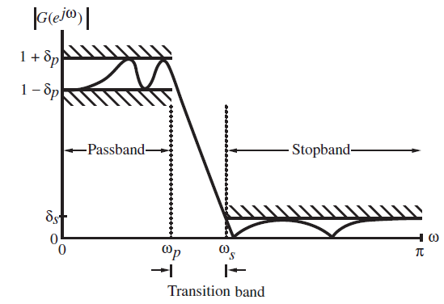

**II.1. Main filters characteristics.**

|  |  |
| --- | --- |
| Characteristic | Description |
| Passband | Unit gain region(ideally): 0dB or 1 non-dB magnitude |
| Stopband | Attenuation region |
| Transition band | Region between passband and stopband |
| Ripple | Amount of Ripple tolerance allowed for filter |
| Filter order | Number of delay components |

**a.Passband, stopband, transition band and ripple**

The *passband* and *stopband* refer to the frequency regions that are to be (ideally) passed unchanged and frequency regions that are to be (ideally) stopped respectively. A *transition band* exists between the stopband and passband. In passband defined by $0≤ω≤ω_{p}$,we require

$1-δ_{P}≤\left|G(e^{jω})\right|≤1+δ_{P}$, for $\left|ω\right|≤ω_{P}$

Or in other words, the magnitude approximates unity within an error of ${±δ}_{P}$. In the stopband, defined by $ω_{s}≤\left|ω\right|≤π$ we require $\left|G(e^{jω})\right|≤ω_{s}$, for $ω_{s}≤\left|ω\right|≤π$, implying that the magnitude approximate zero within an error of $δ_{s}$. The frequencies $ω_{p}$ and $ω_{s}$ are, respectively, called the passband edge frequency and stopband edge frequency. The maximum limits of the tolerances in the passband and stopband, $δ_{P}$ and $δ_{s}$, are called ripples. In most applications, the digital filter specifications are given as indicated in below figure.

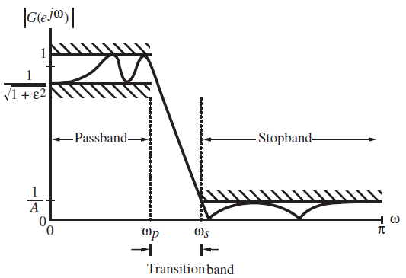

Here, in the passband filter defined by $0≤ω≤ω_{p}$, the maximum and the minimum values of the magnitude are, respectively, unity and $1/{\sqrt{1+ε^{2}}}$. The peak passband ripple in dB is

$$R_{P}=20\log_{10}\sqrt{1+ε^{2 }} dB$$ The maximum ripple in stopband, defined by $ω_{s}≤\left|ω\right|≤π$, is denoted by $1/A$ and the minimum stopband attenuation in dB is given by

$$R_{s}=20\log_{10}A dB$$

**b. Specification frequencies.**

The cutoff frequency refers to the frequency location that determines where the passband and stopband will begin and end. If the passband edge frequency $F_{P}$ and stopband edge frequency $F_{s}$ are specified in Hz along with sampling $F_{T}$ of the defined filter, then the normalized angular edge frequencies in radians are given by

$$ω_{P}=\frac{2πF_{P}}{F_{T}}=2πF_{P}T$$

$$ω_{s}=\frac{2πF_{s}}{F_{T}}=2πF_{s}T$$

**c.Filter order**

The first step in the filter design process is the estimation of the order of the transfer function.

* For the design of FIR digital filters, there are several design formulae for estimating the minimum filter length directly from the digital filter specifications: normalized edge angular frequency $ω_{P}$,normalized stopband edge angular frequency $ω_{s}$,peak passband $δ_{P}$ and peak stopband ripple $δ_{s}$. A rather simple approximate formula developed by Kaiser is given by

$N≅\frac{-20\log_{10}{(\sqrt{δ_{P}δ_{s}})}}{14.6(∆ω)/2π}$ where $∆ω=\left|ω_{P}-ω_{s}\right|$ is the width of the transition band.

* For the design of an IIR digital filter $G(Z)$ based on the conversion of an analog filter $H_{a}(s)$, an analytical formula exists for the estimation of the filter order.

**Design Formulae for estimating the order of the IIR filter.**

1. **Lowpass and High filters**

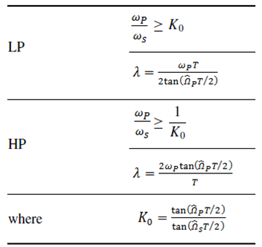

1. **Bandpass and Bandstop filters**

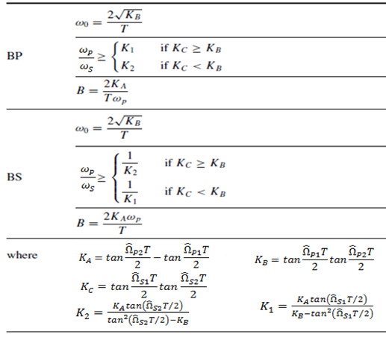

1. **Specific formulas for Butterworth, Chebyshev, and elliptic filters.**

**1. Butterworth filters.**

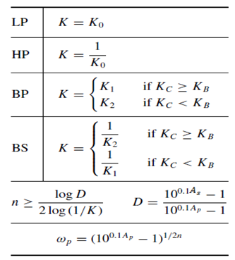

**2. Chebyshev filters.**

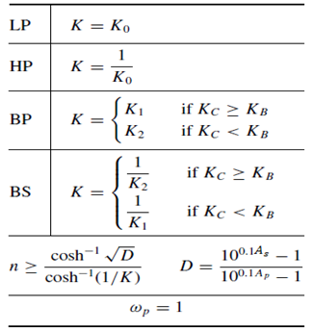

**3. Elliptic filters.**

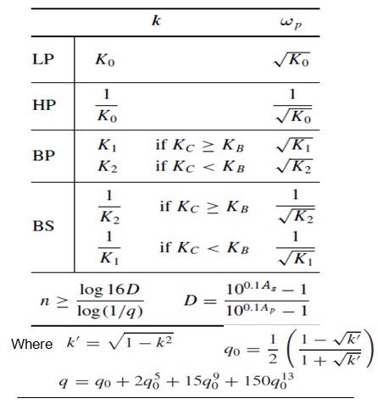

**III. Specifications and Design IIR Filter.**

The most common method of IIR filter design is based on the bilinear transformation defined as $s=\frac{2}{T}\left(\frac{Z-1}{Z+1}\right)$ of a prototype analog transfer function $H_{a}\left(s\right)$. Apply the bilinear transformation to $H_{a}\left(s\right)$, that is $H_{}\left(Z\right)={\left.H_{a}\left(s\right)\right|}_{S=\frac{2}{T}\left(\frac{Z-1}{Z+1}\right)}$. The analog transfer function is usually one of the following types: Butterwork, Type1Chebyshev, Type2 Chebyshev and Elliptic transfer function.

The bilinear transformation is defined as**:**

**Examples of the design IIR filters.**

A. Design a highpass filter that would satisfy the following specifications:



Using a Butterworth, a Chebyshev, and then an elliptic approximation.

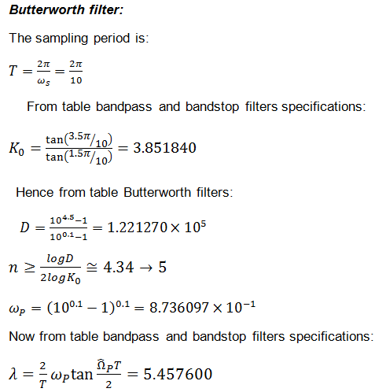

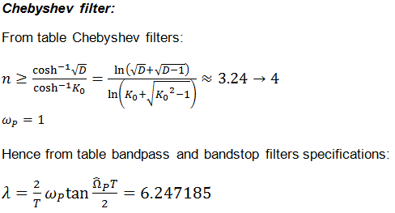

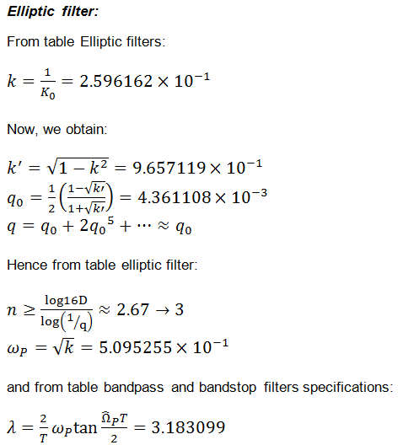

The transfer functions $H_{a}\left(s\right), H_{HP}\left(\overline{s}\right)$ and $H_{D}\left(z\right)$ can be put in the form

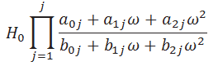

Where $H_{0}$ is a multiplier constant and $ω=s, \overline{s}$ or $z$.

The three filters are plotted in function loss characteristics

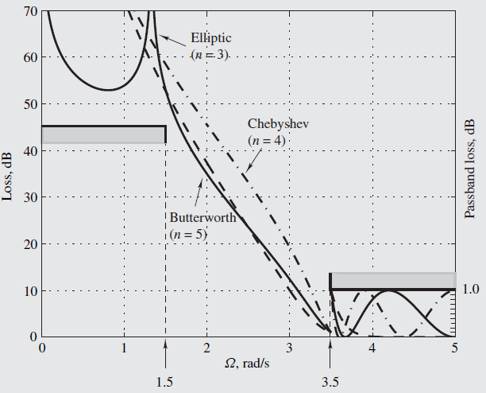

B. Design an elliptic bandpass filter that would satisfy the following specifications:



***Elliptic filter:***

The sampling period is given by:

$T=\frac{2π}{ω_{s}}=\frac{2π}{600}$

From table bandpass and bandstop filters specifications:

$K_{A}=tan\left(\frac{1100π}{600}\right)-tan\left(\frac{900π}{600}\right)=1.398821×{10}^{-1}$

$K_{B}=tan\left(\frac{900π}{600}\right)tan\left(\frac{1100π}{600}\right)=3.308897×{10}^{-1}$

$K_{C}=tan\left(\frac{800π}{600}\right)tan\left(\frac{1200π}{600}\right)=3.234776×{10}^{-1}$

Hence $K_{C}<K_{B}$ and from table elliptic filters:

$k=K_{2}=\frac{K_{A}tan\left({{\hat{Ω}}_{s2}T}/2\right)}{\tan^{2}\left({{\hat{Ω}}_{s2}T}/2\right)-K_{B}}=5.159570×{10}^{-1}$

$ω_{P}=\sqrt{K_{2}}$

$D=\frac{{10}^{4.5}-1}{{10}^{0.1}-1}=1.221270×{10}^{5}$

Now, we obtain:

$k^{'}=\sqrt{1-k^{2}}=8.566144×{10}^{-1}$

$q_{0}=\frac{1}{2}\left(\frac{1-\sqrt{k'}}{1+\sqrt{k'}}\right)=1.933628×{10}^{-2}$

$q=q_{0}+2{q_{0}}^{5}+…≈1.933629×{10}^{-2}$

Hence

$n≥\frac{log16D}{log\left(1/q\right)}≈3.67→4$

Now, from table bandpass and bandstop filters specifications:

$ω_{0}=\frac{2\sqrt{K_{B}}}{T}=1.098609×{10}^{3}$ and $B=\frac{2K_{B}}{T.ω_{P}}=3.719263×{10}^{2}$

The transfer function:

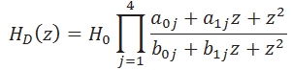

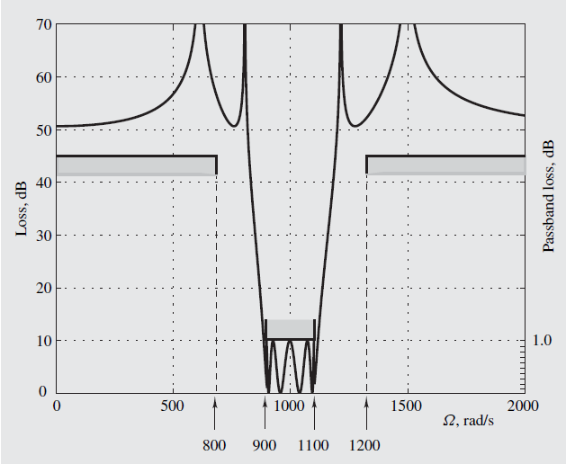

**IV.Conclusion.**

In IIR filters, the approximation problem is usually solved through indirect methods. First, a continuous-time transfer function that satisfies certain specifications is obtained using one of the standard analog-filter approximations. Then a corresponding discrete-time transfer function is obtained using bilinear transformation. In this paper, bilinear transformation is used and is concerned with the indirect approach to the design of IIR filters.

**References**

1. A. Antoniou. *Digital filters: Analysis, design, and applications*. McGraw-Hill,1993.
2. J.F. Kaiser. Nonrecursive digital filter design using the *I*0-sinh window function. *Proc. 1974 IEEE International Symposium on Circuits and Systems*, pages 20-23, San Francisco CA, April 1974.
3. N.J. Fliege. *Multirate Digital Signal Processing*. John Wiley & Sons, 1994.
4. L.W. Couch II. *Digital and Analog Communication Systems*. Prentice Hall,2001.